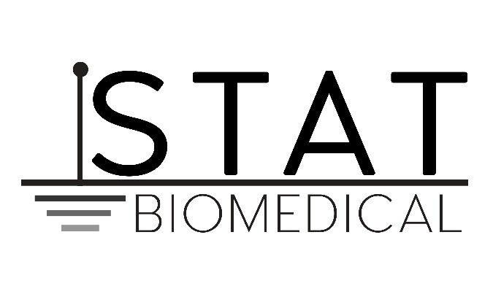

Stat Biomedical Technicians, Inc. is a full-service facility that specializes in the repair, preventative maintenance and safety inspections of biomedical equipment. We have been in business since 1990 and have established a loyal customer following because of the quality services and personalized attention that we offer to all of our clients.

When you contact our office, you will receive the personalized service that your business deserves. As a small business, we are proud of the relationships that we have built with customers, and our technicians offer the knowledge and experience to repair or perform safety inspections on even the most advanced devices.

We service brand new machinery as well as older models of equipment so we can take care of all your biomedical equipment services. When you call our office, you will speak directly with an experienced representative who can make arrangements for the services that you need.

Trust the experts at Stat Biomedical Technicians, Inc. to provide quality customer service, reasonable prices, and reliable and impeccable maintenance and safety inspections for all your medical equipment needs.

